LMS Implementation

Business case

WARNING: This document is uncontrolled unless viewed electronically from its original location. Where an uncontrolled document is used it is the responsibility of the person using it to ensure that it is the latest version.
Contents
ABOUT THIS DOCUMENT 3
VERSION CONTROL 3
EXECUTIVE SUMMARY 4
PROGRAMME RESOURCE 4
CURRENT BUSINESS CONCERNS 4
CURRENT USERS & COSTS 4
LEARNING MANAGEMENT SYSTEM BENEFITS 5
SOLUTION OPTIONS 5
PROGRAMME TIMELINE 6

ABOUT THIS DOCUMENT

Document purpose | To provide justification for the proposed move from our current learning portal, Basecamp, to a Learning Management System (LMS)
Intended audience | All Pitman Liverpool staff
Scope | Learning & Development, Marketing, Sales
Related Documents

VERSION CONTROL

Date | Description of Change | Author | Version No.
2/12/25 | First Draft | Donna | 1.0

Date | Document | Reviewer / Approver | Version No.
 |  | Maje

EXECUTIVE Summary
This business case outlines the rationale for transitioning from Pitman Liverpool’s current learning platform, Basecamp to a LMS. While Basecamp has served as a low-cost and familiar tool for project management and basic communication, it is not designed to support structured training, learner accountability, or the scalable delivery of education services. As learner numbers grow and expectations rise, the limitations of Basecamp are increasingly restricting the overall student experience.
Basecamp’s constraints including limited tracking capability, no structured course delivery, lack of assessments, poor integration of learning content, and manual administrative processes result in increased staff workload and an inconsistent learning journey for students. The absence of robust reporting or analytics further prevents effective monitoring of learner progress, compliance and training outcomes.
Modern LMS solutions, such as 360 Learning, offer significant advantages that directly address Pitman Liverpool’s needs. These include automated enrolment and reminders, structured learning paths, assessments, centralised learning content, mobile access, rich analytics, and the ability to support large learner cohorts with minimal administrative overhead. Such systems create a smooth, engaging user journey for learners while providing management with visibility of performance, ROI, and training impact. Although they carry subscription costs and require initial setup and onboarding, these platforms deliver high long-term value by reducing manual workload and enabling scalable growth.
Three options were considered:
1. remain with Basecamp
2. purchase a COTS LMS such as 360 Learning, or
3. develop a custom in-house LMS
Staying with Basecamp offers familiarity and low upfront costs but does not meet the organisation’s long-term training or scalability requirements. Building a custom LMS would provide full control but would require a significant financial investment and a development timeline.
Recommendation: Following a detailed comparison of cost, capability and future business needs, the recommended option is the adoption of a commercial LMS such as 360 Learning. This solution provides the strongest alignment with Pitman Liverpool’s strategic goals by enhancing the learner experience, improving operational efficiency, strengthening accountability and supporting the growth. Of the business. Overall, transitioning to a dedicated LMS will enable Pitman Liverpool to deliver a consistent, high-quality, scalable learning experience that meets both current and future organisational demands.

Programme Resource

Name | Position
Lindsey Jones | Programme Sponsor/Product Owner
 | Developer
Alexander Maclean | Project Lead
 | Business Analyst
 | Project Manager

CURRENT BUSINESS CONCERNS
Existing Basecamp Processes
Ref | Business Concern | Description
1 | Cost | Low license cost but higher ongoing operational burden, this is seen as a negative as the service and facilities offered with the LMS are limited due to low monthly fee. Because of these limitations, administrative overhead costs can rise especially as the volume of learners grows within Pitman Training.
2 | Lifetime Career Development | Unable to monitor students progressions towards sourcing employment. Basecamp’s product site and learning resources position it as a project management or collaboration platform and don’t necessarily target the significance of a lifetime career development being part of its service, so it is lacking in this area.
3 | User Journey | Unable to embed videos for further studies or learning for students. Current concern is that Basecamp is mainly a project-management tool rather than a purpose-built LMS. As a result, students experience several friction points throughout their learning journey that create operational inefficiencies and limit the quality of the learning experience for the users.
4 | Accountability to complete work | Current system used does not allow facility to upload completed work to Basecamp. Students may have to work across two systems simultaneously. This creates risk of incomplete work or perhaps missed deadlines if accountability is being tracked. Also another concern is that it does not provide structured tracking of lesson completion, assessment progress, time spent learning, or pass/fail indicators making it difficult to hold students accountable for steady progress.

CURRENT USERS & COSTS
What is the cost of using current LMS?
Ref | Plan/Model | Cost
1 | Plus (per-user) unlimited projects, per full-user billing | £11.50–£11.75 per user/month
2 | Pro unlimited (all-users flat fee, billed annually) unlimited users & projects | £225–£230/month
3 | Pro unlimited (all-users flat fee, billed monthly) unlimited users & projects | £265–£270/month

LEARNING MANAGEMENT SYSTEM BENEFITS
The market for learning management systems (LMS) is very competitive. Top of the market LMS’ 360 Learning provide the following features:
360 Learning
Ref | Features | Description
1 | Courses | Collaborative course creation: 360Learning allows subject matter experts within the organisation to create courses quickly without heavy reliance on IT.  Interactive content: Supports quizzes, assignments and multimedia content to enhance engagement and knowledge retention.  Rapid deployment: Courses can be published and updated in real-time, reducing delays in training delivery.
2 | Documentation | Centralised knowledge Repository: Documentation and learning materials are stored in one platform, making it easy to access, update, and manage learning resources.  Version control: Ensures learners always have access to the latest content and avoids confusion with outdated documents.
3 | E-learning | Self-paced learning: Employees can take courses at their own pace, accommodating different schedules and learning styles.  Mobile access: Fully mobile-compatible, enabling learning on-the-go.  Engagement features: Gamification, discussion boards and peer feedback foster motivation and interaction.
4 | Management | Role-based access control: Administrators can assign learning paths based on roles, departments, or skill levels.  Automated workflows: Automatic reminders, course assignments and approvals reduce administrative burden.  Scalable for growth: Supports a growing number of learners without performance issues.
5 | Tracking | Detailed analytics & reporting: Track learner progress, course completion, quiz performance and engagement metrics.  Compliance tracking: Ensures employees complete mandatory courses and certifications.  Insights for improvement: Identify gaps in learning or low engagement to optimize training programs.
6 | Education/Learning impact | Supports continuous learning: Encourages ongoing skill development rather than one-off training.  Peer-to-peer learning: Employees can create content, share knowledge, and collaborate on courses.  Adaptive learning paths: Courses can be personalised based on learner progress and skill level.

solution options
There are three main options for Pitman Liverpool’s LMS:
Option One – Stay with Basecamp?
Staying with Basecamp as their LMS is something to be considered for by Pitman Liverpool due to the low-cost monthly payment and the familiarity of the system within the organisation however I want to consider an analysis of other elements and what will properly benefit the company more with regards to scalability, whilst also providing the best service possible to their students.
Staff are already familiar with Basecamp’s interface and workflows, which will reduce training costs and learning curve leading to minimal disruption. To keep cost to a minimum, if users are already subscribed for collaboration/project management then no extra LMS subscription needed and will avoid expenditure on a new LMS. Basecamp is great for organising tasks, deadlines and team collaboration, as well as it being straightforward and easy to use. No complex setup or administration required which will ultimately lead to minimal administrative overheads and no need for a dedicated LMS admin team.
Limitations of Using Basecamp
Basecamp lacks structured course management, learning paths, assessments, or certification features as it was not initially designed as an LMS which ultimately makes tracking progress and enforcing training compliance difficult and limits professional training delivery. There are also no built-in reporting on course completion, engagement, quiz performance or learning outcomes which can affect monitoring ROI, learner performance and compliance requirements. There is a weak element of scalability for learning using Base Camp and it was not designed for learning. And so managing multiple courses or cohorts is time-consuming and will be affecting the overall user journey experience for students which in the long term can have an impact on the reputation of the business and ability to scale.
Pros of using Basecamp
Summary
- No new software costs; existing subscriptions cover usage.
- Staff already know Basecamp; minimal training required.
- Good for basic file sharing, communication and task management.
- Suitable for small-scale or informal learning.
Cons of using Basecamp
Summary
- Potential hidden costs in admin time, manual tracking, or inefficient processes.
- Not optimised for learning as it lacks features for structured courses.
- Limited LMS capabilities such as quizzes, certificates, learning paths, analytics.
- Difficult to manage larger numbers of learners or formalised training programs.

Option Two – Buy a commercial off the shelf COTS product i.e 360 Learning
360 Learning was designed to manage hundreds or thousands of learners across departments or locations, with automatic enrolment, cohorts and learning paths. This will support business growth and multiple courses without added administrative burden, easily accommodates increasing numbers of staff or students. Enables creation of structured courses, modules, and learning paths so that assignments, quizzes and assessments can be automated. Tracks learner progress, completion rates, engagement, quiz scores, and overall training effectiveness. Provides management with actionable insights to improve training programs and demonstrate ROI. Supports self-paced learning, mobile access and multimedia content. It has benefits of automated enrolment, reminders and reporting which will reduce manual work for administrators leading to freeing up time for managers and trainers to focus on strategic initiatives rather than manual tracking.
Below is an example of a 360 Learning dashboard from the manager’s perspective, showing student progress. This straightforward view allows managers to quickly assess how students are advancing and monitor overall learning and completion.
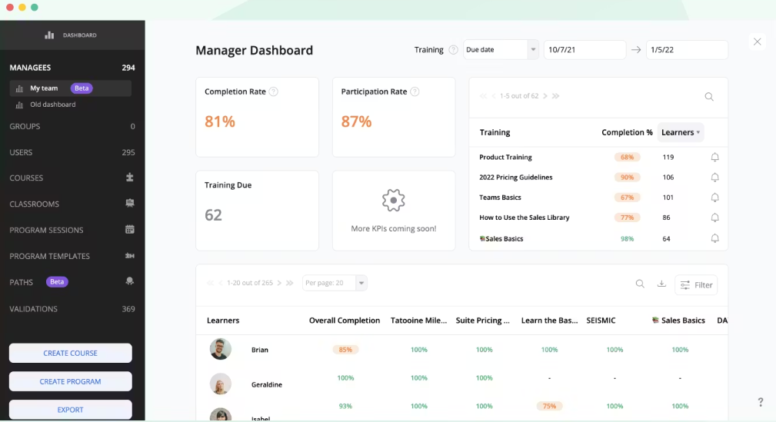

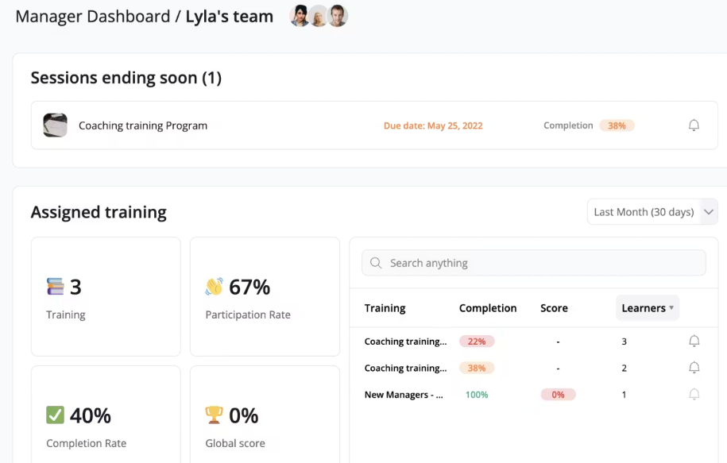
Here is an example of the student’s view and their access; the setup is clear and user-friendly, providing a smoother overall experience for them.
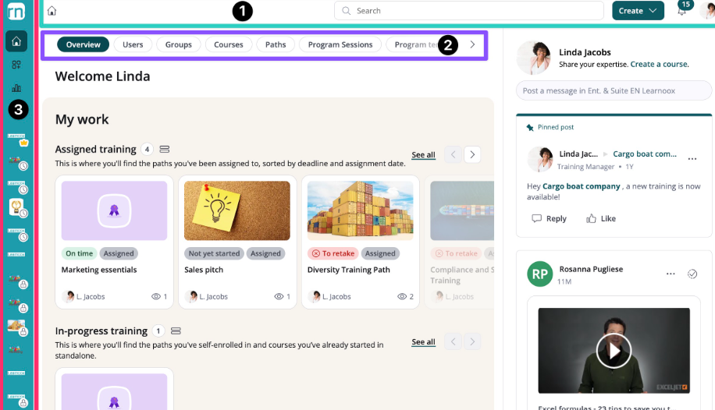

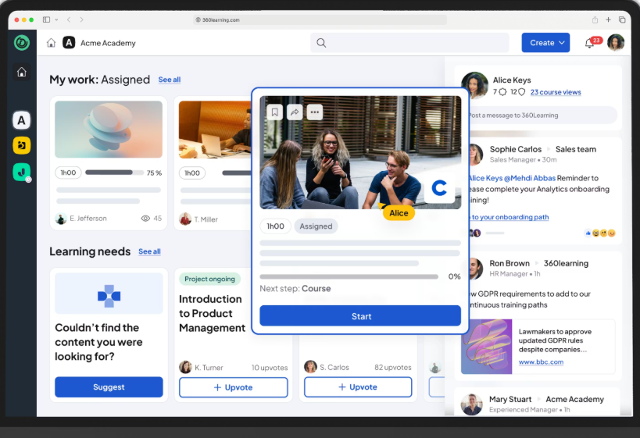

Key factors to consider before migrating to 360 Learning:
Consideration | Reasoning
Cost | 360 Learning requires a paid license, with a higher upfront cost and ongoing cost compared to using Basecamp
Set up | Requires time to migrate content, configure learning paths and onboard staff, this is could require IT support or project management.
Training | Admin team and learners may need training in how to use new LMS, but this could be a minimal risk if training is planned, but the initial migration may be slower.

Cost Benefit Summary for migrating to 360 Learning:
Users | Cost estimate
25 | £160 per month / £1920 annually
50 | £320 per month / £3840 annually
100 | £640 per month / £7680 annually

Pros of implementing 360 Learning:
Summary
- Supports hundreds/thousands of learners, automated workflows, multiple courses, departments, or branches.
- Centralised content library, automated enrolment, reminders, tracking.
- Detailed analytics for management, compliance, and ROI measurement.
- Continuous learning culture, professional development, reduced administrative burden, improved compliance.
Cons of implementing 360 Learning:
Summary
- Subscription costs may increase with user volume.
- Time and resources required for setup and content migration.
- Staff need to learn reporting features; initial setup required.
- Upfront investment (time and cost) but high long-term ROI.

Option Three – Develop their own LMS?
As part of assessing options for replacing the current Basecamp setup Pitman currently have, I explored whether they could actually benefit from developing its own custom LMS. This section outlines the estimated costs, benefits, risks, and overall feasibility of creating an in-house system compared to buying a ready-made solution.

Estimated costs from researching:
The cost of building even a basic, fully-working system is high. A realistic estimate ranges from:
- £150,000 - £250,000 for a minimum-viable system
- £250,000 - £500,000+ for a more robust platform including reporting dashboards, assessment tools, integrations and a polished user experience
This would include things to implement such as:
- Software development
- Testing
- Project management
- Hosting infrastructure setup
- Data security and compliance work
We would also need to consider the requirements and cost of the up keep of the system, do deal with any tech issues, improving the system and security features.

Timeframe for the proposal of Pitman Liverpool LMS
A realistic development timeline would be:
- 3–6 months for a very basic MVP
- 6–12 months for a full-featured LMS suitable for daily use
- 12+ months for advanced functionality or mobile app support
This is a lot longer than simply purchasing an COTS which can usually be deployed within weeks.
Benefits of building a custom LMS
Despite the high cost there are some benefits to creating a bespoke system. Pitman Liverpool would own the platform, decide its roadmap and avoid being dependent on an external vendor for features or changes to pricing. The system could be built exactly around current training processes and workflows rather than adapting the business to fit the system, it would be completely tailored to suit Pitman Liverpool’s requirements.
Developing custom software is significantly more expensive than using an existing LMS. Even basic functionality requires large initial investment. Pitman Liverpool would become responsible for hosting, security, updates and compliance much of which is handled automatically by modern cloud-based LMS vendors. Buying an LMS delivers immediate improvement. Building one delays benefits by 6–12 months or even longer.
Overall assessment: Is building an LMS cost-effective?
Based on the estimated financial and time costs, building a custom LMS is not the most cost-effective option for Pitman Liverpool at this time.
While owning our own system provides flexibility, the investment required is substantial compared to the cost of purchasing a ready-made LMS. Modern platforms typically cost a fraction of what it takes to build and maintain an in-house system and already include the features that training providers usually need.

ReCOMMEDATIONS
Based on the analysis of current challenges, business needs and the available solution options, it is recommended that Pitman Liverpool transition from Basecamp to a LMS, such as 360 Learning.
Basecamp, while it is cost-effective as a project management tool, is not designed to support structured learning, student tracking or scalable training delivery. These limitations result in increased administrative effort, limited learner accountability and do not offer a smooth user journey for its students. As Pitman Liverpool continues to grow, the current system will restrict both the operational side of things as well as the student experience.
Implementing a COTS LMS like 360 Learning will provide Pitman Liverpool with a purpose-built, scalable platform that supports automated enrolment, structured learning paths, assessments, real-time progress tracking and detailed analytics. This transition will reduce manual workload, improve learner engagement, enhance course delivery and provide management with clear visibility of student performance and return on investment. Although the introduction of using 360 Learning will involve a subscription cost and initial setup effort, the long-term benefits and enhanced overall learning experience outweigh the costs of this possible migration.
Migrating to a 360 Learning will enable Pitman Liverpool to deliver a consistent, high quality learning experience while supporting business growth & scalability.

